**Rock, Paper, Scissors Project**

**for**

**Software Development**

**Prepared by Paul Mahon**

**Paul Mahon**

Student No. 14119145

Email: paul.mahon@student.ncirl.ie

**Revision 1.0**

**Date: 7th December 2014**

**Change History**

Use this table to document the revisions made to this document. This should only be used if the changes being made require a version change and the re-distribution of this document.

|  |  |  |  |
| --- | --- | --- | --- |
| **Revision** | **Date** | **Changed by** | **Description of change** |
| 1.0 | 01/12/2014 | Paul Mahon | Document Creation |
|  |  |  |  |
|  |  |  |  |
|  |  |  |  |
|  |  |  |  |
|  |  |  |  |
|  |  |  |  |

**Amendments**

Use this table to document the amendments to specific pages. These changes should not require the re-distribution of this document.

|  |  |  |  |
| --- | --- | --- | --- |
| **Revision** | **Date** | **Changed by** | **Description of change** |
|  |  |  |  |
|  |  |  |  |
|  |  |  |  |

**Table of Contents**

1. Class Diagram 4

2. Application 5

2.1. Input 5

2.2. Process 5

2.3. Output 5

3. Screen Shots 6

3.1. All Games Played 6

3.2. All Lives Lost 9

4. Application code 10

5. Instantiable Code 11

# 

# Class Diagram

This is the class diagram for the games Rock, Paper, Scissors created by Paul Mahon.

The class RPSGAME2014App is the application class which is user to call the instantiable class call RPSGAME2014. The instantiable class uses the scanner and random classes.

All input, process and output is performed by the instantiable class.



# Application

## Input

Input is captured using the Scanner class. Input that we needed to capture

* Number of games the player wishes to play
* Players choice of shape
* Computers RANDOM choice of shape

## Process

A set amount of lives (3) have been given to the player at the start. When the number of games has been inputted then the application will begin using a “Do” “While” loop to determine the winner from shape choices made.

The loop will continue until either all games are played or all lives are lost, whichever comes first.

## Output

For every game played output is given in the forms below

How many games do you want to play?

2 (Number of games to be played)

Please choose the number for your shape:

Rock = 1

Paper = 2 No. Games Remaining: 2 (Number of games to be played)

Scissors = 3

1 (Players choice)

|-----------------------------------------------------------|

Players Chooses No.: 1 (Playerschoice)

Computers Chooses No.: 3 (Computer choice)

Players shape is ROCK (Players choice in English)

Computers shape is SCISSORS (Computers choice in English)

Rock beats Scissors so PLAYER Wins! (Output from the calculateWinner loop)

| Player Wins: 1 Player Losses: 0 (Players results from games played)

| Computer Wins: 0 Computer Losses: 1 (Computers results from games played)

|------------------------------------------------------------------------------------------------|

Lives Left = 3 (Lives remaining)

In section “5” of this document parts of the code have been marked with “INPUT”, “PROCESS” and “OUTPUT” for the example that is given above.

# Screen Shots

## All Games Played

When the game is executed the user is prompted to choose how many games he/she would like to play.



For the purpose of this report the player has chosen “5” games

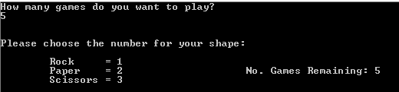

The Player has made a choice of shape number “1” ROCK.

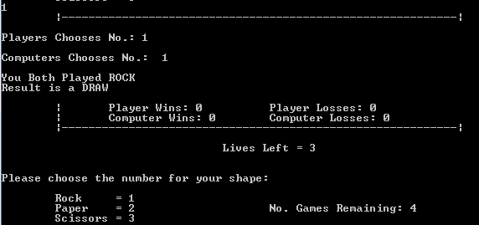

After a draw from the previous game the player still has all 3 lives. The player is prompted to choose again.

The Player has made a choice of shape number “2” PAPER.

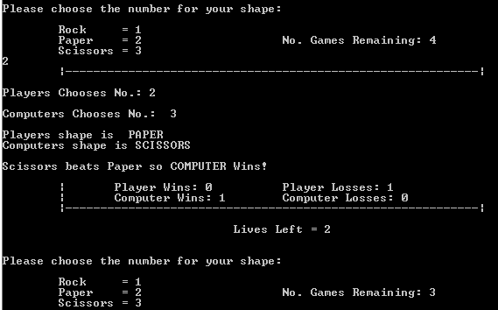

After a loss from the previous game the player still has 2 lives. The player is prompted to choose again.

The Player has made a choice of shape number “3” SCISSORS.

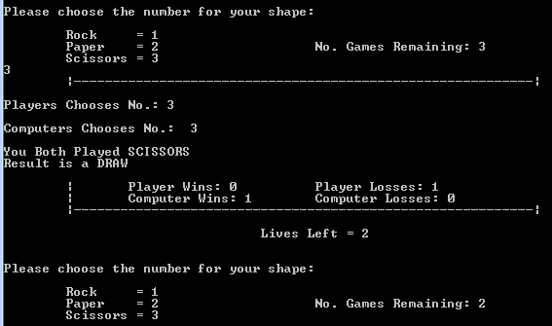

After a draw from the previous game the player still has 2 lives. The player is prompted to choose again.

The Player has made a choice of shape number “1” ROCK.

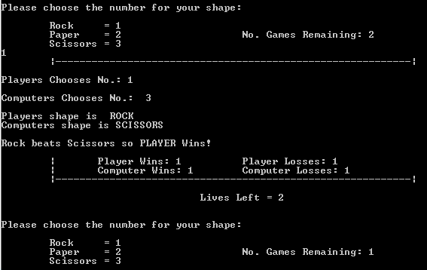

After a win from the previous game the player still has 2 lives. The player is prompted to choose again. Final Game.

The Player has made a choice of shape number “2” PAPER. It’s a draw and all “5” games have completed.

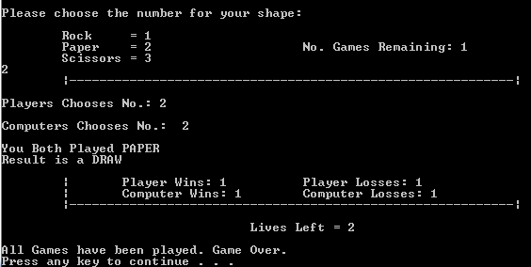

## All Lives Lost

The below print screen is not from the above game. This is just to illustrate what happens if all lives are lost before the all games have been played,

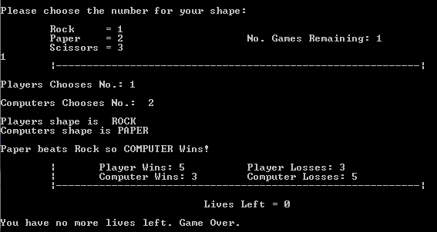

# Application code

/*

* RPSGame2014App.java - This application plays the Rock Paper Scissors game

* Application Class

* @author Paul Mahon

* student ID 14119145

* @date 20/11/14

*/

public class RPSGame2014App{

public static void main(String arg[]){

//declare variables & instantiate

RPSGame2014 Game = new RPSGame2014();

Game.gameLoop();

}

}

# Instantiable Code

/*

* RPSGame2014.java - Rock Paper Scissors Game

* Instantiable Class

* @author Paul Mahon

* Student ID: 14119145

* 20/11/14

*/

import java.util.Random;

import java.util.Scanner;

public class RPSGame2014 {

private int wins = 0;

private int losses = 0;

private int games;

private int livesLeft = 3;

private int playerShape = 0;

private int playerShapeChoices [][];

private int computerShapeChoices [][];

private int rock=1;

private int paper=2;

private int scissor=3;

private int computer;

Private Scanner input = new Scanner (System.in);

**INPUT** //Ask the user how many games he/she wishes to play

public void captureGames(){

System.out.println("How many games do you want to play?");

games = input.nextInt();

//2D array used to captures the players shape choice for each game played

playerShapeChoices = new int [games][50];

//2D array used to captures the computers shape choice for each game played

computerShapeChoices = new int [games][50];

}

//Prompt the player for shape choice & display number of games

public void getPlayerShape(){

System.out.println();

System.out.println();

System.out.println("Please choose the number for your shape:");

System.out.println();

System.out.println(" Rock = 1");

System.out.println(" Paper = 2" +" No. Games Remaining: " + games);

System.out.println(" Scissors = 3");

**INPUT** //Capture input from the players choice of shape using the scanner & display his/her choice

playerShape = input.nextInt();

System.out.println(" |-----------------------------------------------------------|");

System.out.println();

System.out.println("Players Chooses No.: " + playerShape);

}

**PROCESS with OUTPUT**

//All the below code will calcuate the results of each games based on choices made by the player and computer

public void calculateWinner(){

//The below code will calculate if the game was a DRAW

if(playerShape == computer){

if(playerShape == scissor){

System.out.println("You Both Played SCISSORS");

}

if(playerShape == rock){

System.out.println("You Both Played ROCK");

}

if(playerShape == paper){

System.out.println("You Both Played PAPER");

}

System.out.println("Result is a DRAW");

System.out.println();

System.out.println(" | Player Wins: " + wins + " Player Losses: " + losses);

System.out.println(" | Computer Wins: " + losses + " Computer Losses: " + wins);

System.out.println(" |-----------------------------------------------------------|");

}

//This is the code when the PLAYER WINS using SCISSORS

if(playerShape == scissor)

if(computer == paper){

System.out.println("Players shape is SCISSORS");

System.out.println("Computers shape is PAPER");

System.out.println();

System.out.println("Scissor beats Paper so PLAYER Wins!");

System.out.println();

wins++;

System.out.println(" | Player Wins: " + wins + " Player Losses: " + losses);

System.out.println(" | Computer Wins: " + losses + " Computer Losses: " + wins);

System.out.println(" |-----------------------------------------------------------|");

}

//This is the code when the COMPUTER WINS using ROCK

else if(computer == rock){

System.out.println("Players shape is SCISSORS");

System.out.println("Computers shape is ROCK");

System.out.println();

System.out.println("Rock beats Scissors so COMPUTER Wins!");

System.out.println();

losses++;

System.out.println(" | Player Wins: " + wins + " Player Losses: " + losses);

System.out.println(" | Computer Wins: " + losses + " Computer Losses: " + wins);

System.out.println(" |-----------------------------------------------------------|");

livesLeft = livesLeft -1;

}

//This is the code when the PLAYER WINS using ROCK

if(playerShape == rock)

if(computer == scissor ){

System.out.println("Players shape is ROCK");

System.out.println("Computers shape is SCISSORS");

System.out.println();

System.out.println("Rock beats Scissors so PLAYER Wins!");

System.out.println();

wins++;

System.out.println(" | Player Wins: " + wins + " Player Losses: " + losses);

System.out.println(" | Computer Wins: " + losses + " Computer Losses: " + wins);

System.out.println(" |-----------------------------------------------------------|");

}

//This is the code when the COMPUTER WINS using PAPER

else if (computer == paper){

System.out.println("Players shape is ROCK");

System.out.println("Computers shape is PAPER");

System.out.println();

System.out.println("Paper beats Rock so COMPUTER Wins!");

System.out.println();

losses++;

System.out.println(" | Player Wins: " + wins + " Player Losses: " + losses);

System.out.println(" | Computer Wins: " + losses + " Computer Losses: " + wins);

System.out.println(" |-----------------------------------------------------------|");

livesLeft = livesLeft -1;

}

//This is the code when the PLAYER WINS using PAPER

if(playerShape == paper)

if(computer == rock){

System.out.println("Players shape is PAPER");

System.out.println("Computers shape is ROCK");

System.out.println();

System.out.println("Paper beats Rock so PLAYER Wins!");

System.out.println();

wins++;

System.out.println(" | Player Wins: " + wins + " Player Losses: " + losses);

System.out.println(" | Computer Wins: " + losses + " Computer Losses: " + wins);

System.out.println(" |-----------------------------------------------------------|");

}

//This is the code when the COMPUTER WINS using SCISSORS

else if (computer == scissor){

System.out.println("Players shape is PAPER");

System.out.println("Computers shape is SCISSORS");

System.out.println();

System.out.println("Scissors beats Paper so COMPUTER Wins!");

System.out.println();

losses++;

System.out.println(" | Player Wins: " + wins + " Player Losses: " + losses);

System.out.println(" | Computer Wins: " + losses + " Computer Losses: " + wins);

System.out.println(" |-----------------------------------------------------------|");

livesLeft = livesLeft -1;

}

if(games==0){

System.out.println();

System.out.println("Game Over - Number of Games Choosen has been reached - Game Over!");

}

}

**PROCESS**

//The below DO WHILE loop will allow the game to run until lives are all gone or number of games has been played.

public void gameLoop(){

captureGames();

do{

//Get player shape

getPlayerShape();

//Allow the computer to generate a shape choice

Random computerShape = new Random();

computer = 1+computerShape.nextInt(3);

System.out.println();

System.out.println("Computers Chooses No.: " + computer);

System.out.println();

//Calculate the winner

**PROCESS**

calculateWinner();

//Display Livesleft and decrease the number of games

System.out.println();

System.out.println(" Lives Left = " + livesLeft);

games = games - 1;

//Keep track of all lives until they reach 0 and then stop the program

if (livesLeft <= 0){

**OUTPUT**

System.out.println();

System.out.println("You have no more lives left. Game Over.");

break;

}

}

while (games > 0);

**OUTPUT**

System.out.println();

System.out.println("All Games have been played. Game Over.");

//Traverse the playerShapeChoices array and display the choices for the game.

Unfortunately I was unsuccessful in getting this part working, so I remarked it out. Because the player choice array did not work I didn’t even create the computer choice array.

/* for (int i = 0; i < playerShapeChoices.length; i++){

System.out.println(playerShapeChoices "Game Number "[i] + " ");

for (int j = playerShape; j < playerShapeChoices[i].length; j++){

System.out.println("Shape Choices: " + j + "(Rock = 1, Paper = 2, Scissors = 3)");

}

}*/

}

}